Scaling & Architecture, Day 7/25: CAP Theorem 🧵

If you've ever been in a system design interview, you've probably heard this:
"You can only pick 2 out of 3: Consistency, Availability, Partition Tolerance."
And if you said that in an interview I was conducting, I'd push back. Because that framing is wrong. Or at least, it's dangerously incomplete.
CAP theorem is not a menu where you pick your favourite 2 items. It's a statement about what happens when things go wrong in a distributed system.
Here's the actual statement:
In a distributed system, when a network partition occurs, you must choose between consistency and availability. You cannot have both during the partition.
That "when a network partition occurs" part is everything. It's the part most people skip.
When the network is healthy, you get all three. No tradeoff needed. The tradeoff only kicks in when nodes can't talk to each other. And the question becomes: what does your system do in that moment?
Let me break down what each of these actually means in practice. Not the textbook version. The production version.
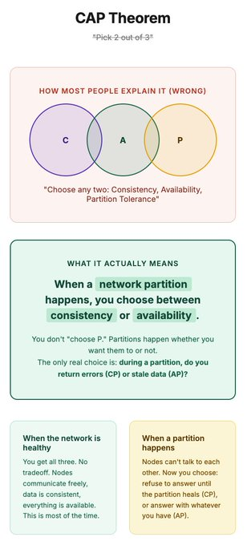

What C, A, and P actually mean
Let me explain each one without the academic language.
Consistency (C)
Every read returns the most recent write. If I update my profile name to "Puneet" and you read it 1 millisecond later from a different server, you see "Puneet." Not the old name. Not a stale copy. The latest version.
In practice this means: all nodes agree on the current state of the data at all times. If they can't agree, they refuse to answer rather than risk giving you wrong information.
Availability (A)
Every request gets a response. No errors. No timeouts. The system always responds, even if the data it returns might not be the very latest.
In practice this means: every node that's up will answer your request. It won't say "sorry, I need to check with the other nodes first." It gives you what it has, even if that's slightly stale.
Partition Tolerance (P)
The system keeps working even when the network between nodes is broken. Messages between servers get lost or delayed. Some servers can't reach other servers.
In practice this means: your system doesn't just crash because two data centres can't talk to each other. It keeps running and makes the best decision it can.
Here's the key insight that changes everything:
You don't choose P. In any real distributed system, network partitions WILL happen. It's not a question of if. Cables get cut. Data centres lose connectivity. Cloud regions have outages. P is not optional. It's a fact of life.
So the real question is simpler than "pick 2 out of 3":
When a partition happens, do you choose consistency or availability?
That's it. That's the actual CAP tradeoff.
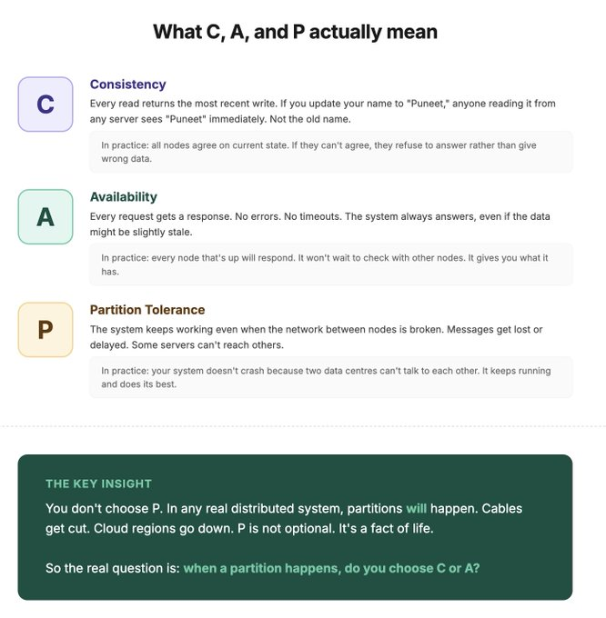

CP vs AP: what actually happens during a partition
Let me make this concrete with a real scenario.
You have a database with two nodes. Node A in Mumbai. Node B in Singapore. They replicate data between them. Everything is working fine.
Then the network link between Mumbai and Singapore goes down. The nodes can't talk to each other. This is the partition.
A user in Mumbai writes: "update my balance to ₹5000"
Node A (Mumbai) has the update.
Node B (Singapore) does not. It still shows the old balance.
Now a user reads from Node B. What happens?
If you chose CP (Consistency + Partition Tolerance):
Node B knows it can't verify it has the latest data. So it refuses to answer. Returns an error. "Sorry, I can't serve this request right now."
The user gets an error. But they never see wrong data. When the partition heals, both nodes sync up and everything is correct again.
If you chose AP (Availability + Partition Tolerance):
Node B serves whatever it has. The old balance. The user gets a response. It's fast. But it might be wrong. It might show ₹3000 when the real balance is ₹5000.
The user gets a response every time. But they might see stale data until the partition heals and the nodes sync.
Neither is "better." It depends on the domain.
For a bank balance? CP. Showing a wrong balance is worse than showing an error. People make financial decisions based on that number.
For your Instagram feed? AP. Missing the latest post for a few seconds is invisible. But if Instagram showed an error every time there was a network blip between data centres, the app would feel broken.
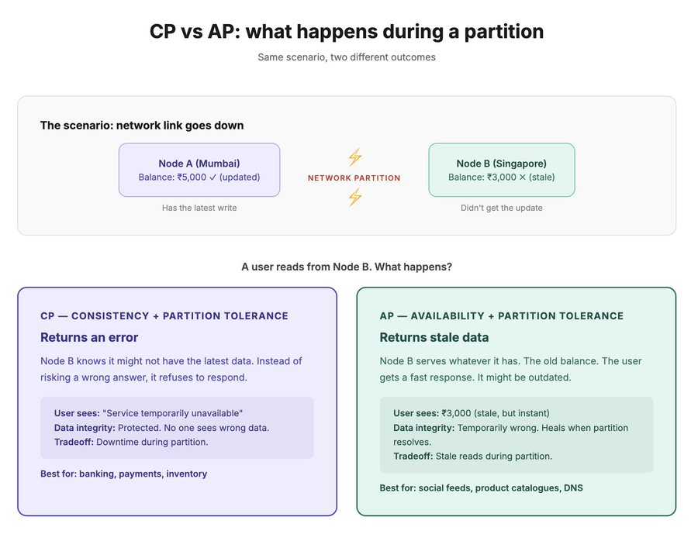
Real systems and their CAP choices
Let me give you actual examples so this stops being abstract.
CP systems (consistency over availability):
- Traditional banks and payment systems. When the network is degraded, they reject transactions rather than risk double-spending or showing wrong balances. You've seen this. "Transaction failed, please try again." That's CP in action.
- Google Spanner. Uses TrueTime (atomic clocks + GPS) to maintain global consistency. During a partition, it waits for consensus. Reads may be slower but they're always correct.
- ZooKeeper / etcd. Coordination services that store critical config and leader election data. If they can't guarantee consistency, the entire cluster can make conflicting decisions. Correctness over speed.

AP systems (availability over consistency):
- Cassandra. Designed for high availability. Every node can accept reads and writes. During a partition, different nodes might have different data. It resolves conflicts later using "last write wins" or custom merge strategies.
- DynamoDB (default settings). Eventually consistent reads are the default. Your read might be slightly stale. But it always responds.
- DNS. Your browser's DNS cache might have an old IP address for a few minutes after a change. Nobody cares. It updates eventually. Availability matters more than instant consistency for DNS.

The pattern you'll notice:
CP systems tend to be things where money, coordination, or safety is involved. Getting the wrong answer is worse than getting no answer.
AP systems tend to be things where user experience and uptime matter more than perfect accuracy. Getting a slightly stale answer is better than getting an error.
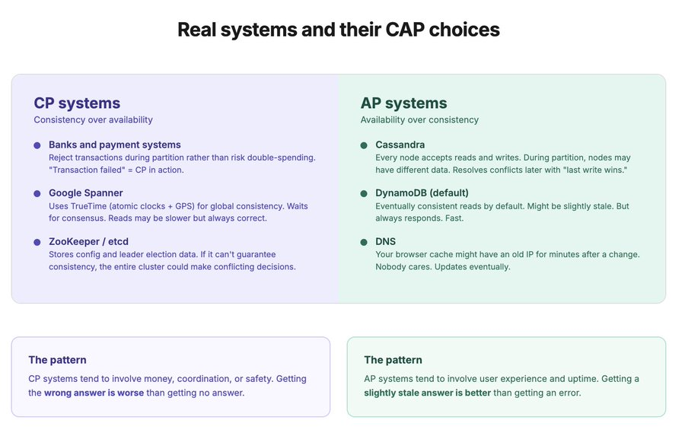

CAP is not a system-level decision. It's a per-feature decision.
Let me say that again because interviewers love this answer:
Within the same application, different features should have different CAP tradeoffs.

Take an e-commerce platform:
- Product catalogue → AP. Show the cached version. If a product description is 30 seconds stale, nobody notices.
- Inventory count on the last item → CP. If you show "1 in stock" when it's actually 0, you just oversold. That's a support ticket, a refund, and a frustrated customer.
- User reviews → AP. Missing the latest review for a few seconds is invisible.
- Payment processing → CP. You cannot process a payment based on stale data. Ever.
- Shopping cart → AP with conflict resolution. Two tabs adding items? Merge the carts later. Don't block the user.

Same platform. Five different features. Three are AP. Two are CP. All correct for their context.
How to talk about this in interviews:
When someone asks "is your system CP or AP?" the best answer is:
"It depends on the feature. Let me walk through which parts need strong consistency and which ones can tolerate eventual consistency."
That answer shows you actually understand CAP instead of just memorising it.

One more thing: PACELC
CAP only describes what happens during a partition. But what about when things are normal? That's where PACELC comes in:
During a Partition, choose A or C.
Else (no partition), choose Latency or Consistency.
Even when the network is healthy, there's a tradeoff between how fast you respond and how consistent your data is. Synchronous replication = consistent but slower. Async replication = faster but briefly stale.
CAP is about failure mode. PACELC is about the full picture.
